**Climate Feedbacks**

In early 1977 President Jimmy Carter was urging Americans to lower their home temperatures to 65F in an effort to conserve energy. During some unseasonably cold weather that winter President Carter and his wife Rosalynn started using an electric blanket to keep warm instead of turning up the thermostat in the White House. This particular electric blanket had dual controls—one for President Carter’s side and one for Rosalynn’s. In his autobiography *Living Faith* President Carter describes a funny episode involving that electric blanket which happens to be example of a feedback loop:

*During each of the increasing cold winter nights, we argued about the temperature of our electric blanket. Whenever I said it was too warm, Rosalynn said it was too cold, and vice versa.*

*One morning after I returned from an overnight trip to New York, and she met me at the front door with a warm hug and a smile. “I think our marriage is saved,” she said. “I just discovered that our dual blanket controls have been on the wrong sides of the bed, and each of us was changing the temperature of the other’s side.”*

In a normal situation an electric blanket is used to keep a person warm. If that person gets cold, they use the controller to turn the electric blanket up. If the person becomes too warm, they use the controller to turn the blanket down. The temperature of the person is feeding back to control the temperature of the electric blanket. This is an example of a negative feedback loop where the system, in this case body temperature, works to maintain equilibrium.

Since the Carters inadvertently switched controllers they created a slightly more complex feedback loop. If President Carter gets too warm, he unknowingly turns down Rosalynn’s controller. She then begins to feel cold so she turns up her controller—which is actually President Carter’s. He gets even warmer and then turns down Rosalynn’s controller further. This feedback look continues to happen causing both President Carter and Rosalynn to be uncomfortable. This is an example of a positive feedback loop where the systems output works to amplify the input creating a chain reaction.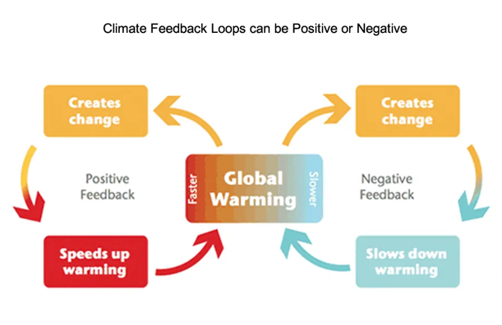

There are many examples of feedback loops all around us such as fruit ripening, fashion trends, and even the rise of memes. In this lesson we will be focusing on climate feedback loops and modeling their effect on global warming. These complex feedback loops are playing an important role in climate change and scientists are working to understand their overall effect on global warming.

**Before playing the Climate Feedbacks game talk with a partner about the questions below and then write your answers.**

1. Lists three or more feedback loops that you can think of or have observed.

____________________________________________________________________________________________________________________________________________________________________________________________________________________________________

1. Using your own words describe on of the feedback loops from questions 1. Is it a positive or negative feedback loop?

______________________________________________________________________________________________________________________________________________________________________________________________________________________________________________________________________________________________________________________________________________________________________________________________________

1. Draw a diagram of the feedback loop you described above.

**Climate Feedbacks Game**

**Materials Per Group (3-5 players):**

* Game board
* One dice and one marker
* Game rules card
* Set of nine climate feedback cards

**Game Rules:**

*Setup:* Shuffle and place climate feedback cards face-down in a stack. Place the game piece on start. Decide which player goes first.

*Game Play:* Players take turns. Each turn, takes the following three steps:

1. Pick a climate feedback card
2. Identify whether the feedback on the card is positive (amplifying) or negative (weakening). Discuss this with the group.
3. Roll the dice the number of times indicated on the card (1, 2, or 3)
4. Add the value of all dice. If the feedback is positive (amplifying) move that number of spaces clockwise. If the feedback is negative (weakening) move that number of steps counter-clockwise.
5. The player identifies which component(s) of the earth system are involved. Place the card in the appropriate spot in the center of the board.

*End of the Game:*

Continue until there are no cards left. Read the climate feed back parameter (λ) at the final position of your game piece. The equilibrium climate sensitivity—ECS-- (warming in degrees Celsius do to a doubling of CO2) is:

ECS=3.6/λ

Compare your answers to the climate feedback cards with the answer key and get your groups climate feedback knowledge score and then answer the questions below:

0-3 Correct: Ask someone to explain feedbacks and try again

4-6 Correct: Getting the hang of it. Play again and keep practicing.

7-8 Correct: Impressive, your group understands how climate feedbacks work

9 Correct: You are a climate feedback expert.

**Climate Feedback Questions:**

Calculate the climate sensitive for your board. According to scientists, the ECS of earth is between 2.5 and 4 degrees Celsius. How does this compare to your board

___________________________________________________________________________________________________________________________________________________________________________________________________________________________________________________

Choose a positive feedback from the climate feedback cards. Using the space below make a diagram that explains this feedback.

Choose a negative feedback from the climate feedback cards. Using the space below make a diagram that explains this feedback.

Based on your game board and your boards calculated ECS value what is the predicted effect on global warming?

_____________________________________________________________________________________________________________________________________________________________________________________________________________________________________________________________________________________________________________________________________________________________________________________________________________________

Scientists are creating complex computer models for climate feedback loops. Why are is modeling important in understanding the effect of climate feedback loops?

_____________________________________________________________________________________________________________________________________________________________________________________________________________________________________________________________________________________________________________________________________________________________________________________________________________________

Mitigation of climate change is the act of slowing the process of climate change. Adaptation of climate change is the act of creating ways to live with the effects of climate change. What careers and technologies would you be excited to be a part of in the future to help mitigate and or adapt to climate change?

_____________________________________________________________________________________________________________________________________________________________________________________________________________________________________________________________________________________________________________________________________________________________________________________________________________________

**Use this page to make diagrams of the climate feedback cards, take notes, and answer questions:**