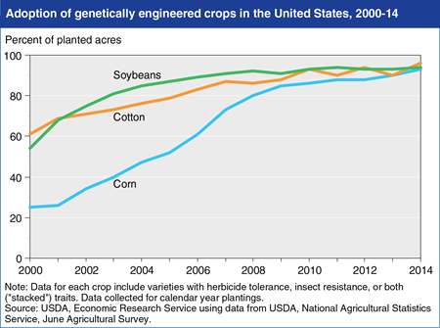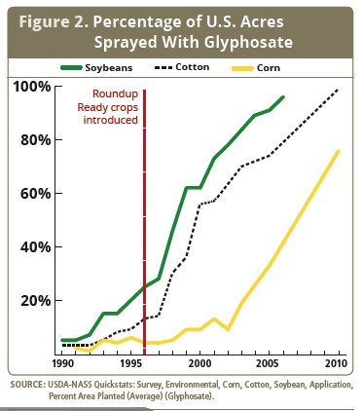

Herbicide resistant crops introduced

Figure: Percentage of U.S. Acres Sprayed with Glyphosate (a specific type of herbicide)

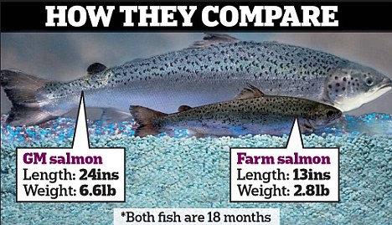 **Genetically Modified (GM) Salmon**

Source: Globalresearch.ca

Source: CSU Extension Fact Sheet, August 2014

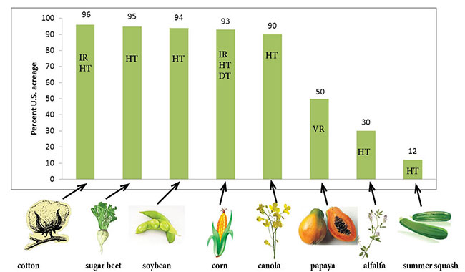

**Percent of acres of U.S. farmland that is planted with genetically modified crops**

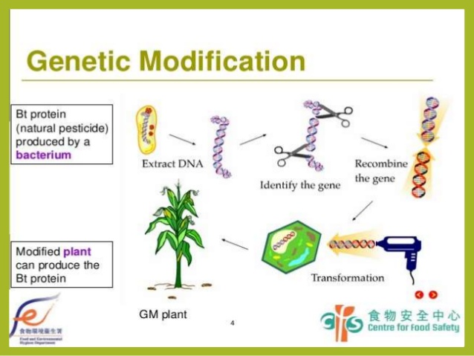

Transform genes to insert into plant cells

Modify the gene

Regenerate transformed cells as plants

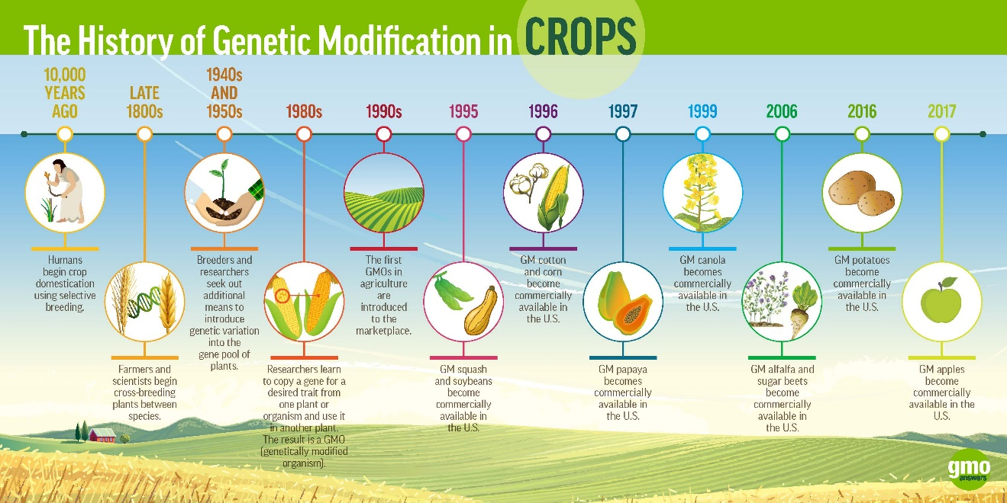

Source: GMO Answers