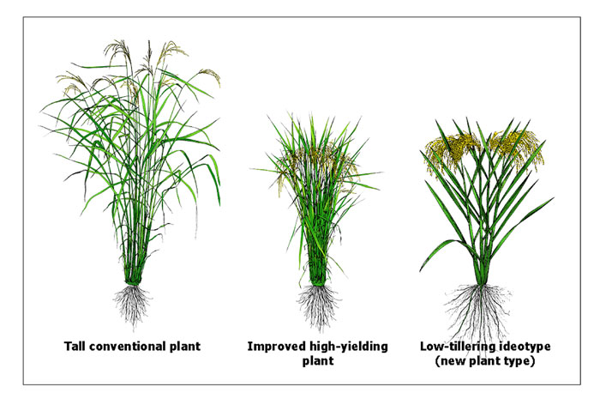**RICE**

Non-Domesticated Rice Green Revolution Rice

**Wheat**

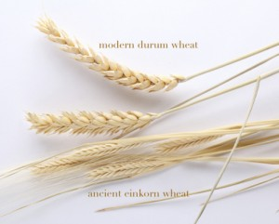

Green Revolution  
Wheat

Non-Domesticated  
Wheat

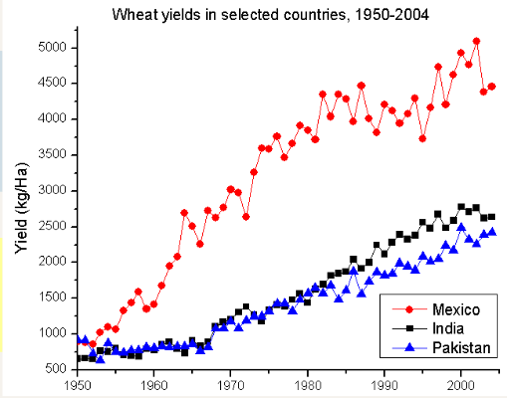

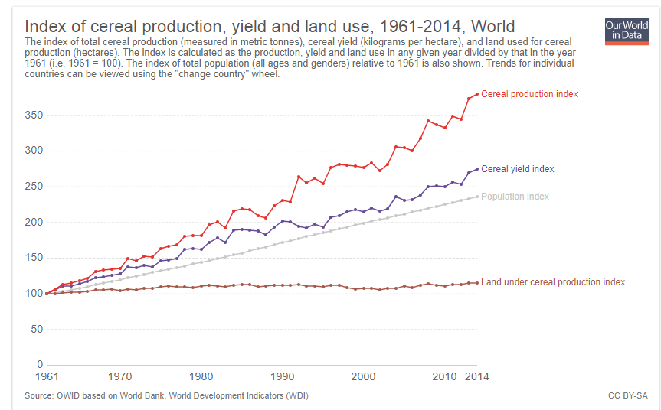

**Global Grain Production, Yield, and Land Use, 1961 - 2014**

Production

Yield

Population

Land Under Cultivation

