**HS BABY ALIEN TEACHER GUIDE**

**BACKGROUND**

(The “SpongeBob Genetics” activity is a lead-in to this activity and contains foundational background information and concepts. It can be found on the SMILE website.)

In this activity, students learn about heredity and how traits are passed on to each generation by creating a baby alien. First discuss that genes are units of heredity. There are two alleles, usually one is dominant and the other is recessive. Dominant alleles have a capital letter (e.g. R). Recessive alleles have a lower case letter (e.g. r). If both alleles are different, it is heterozygous (e.g. Rr). Genetic makeup (letters) is called genotype (e.g. Rr, RR, rr). Physical characteristics are phenotype (e.g long legs).

**Punnett Squares**

The Punnett Square is a square diagram that is used to predict the genotypes of a particular cross or breeding experiment. It is used by biologists to determine the probability of an offspring having a particular genotype.

Example:

Parent 1 genotype – Rr

Parent 2 genotype – RR

Punnett Square

|  |  |  |
| --- | --- | --- |
|  | R | r |
| R | RR | Rr |
| R | RR | Rr |

**Hardy – Weinberg Equation (Information sourced from nature.com), PowerPoint Slide #17**

The Hardy – Weinberg Equation is a mathematical equation that can be used to calculate the genetic variation of a population at equilibrium. The equation is an expression of the principle known as Hardy-Weinberg equilibrium, which states that the amount of genetic variation in a population will remain constant from one generation to the next in the absence of disturbing factors. The Hardy-Weinberg equation is expressed as: **p2 + 2pq + q2 = 1**, where p is the frequency of the "A" allele and q is the frequency of the "a" allele in the population. In the equation, p2 represents the frequency of the homozygous genotype AA, q2 represents the frequency of the homozygous genotype aa, and 2pq represents the frequency of the heterozygous genotype Aa. In addition, the sum of the allele frequencies for all the alleles at the locus must be 1, so p + q = 1. If the p and q allele frequencies are known, then the frequencies of the three genotypes may be calculated using the Hardy-Weinberg equation. In population genetics studies, the Hardy-Weinberg equation can be used to measure whether the observed genotype frequencies in a population differ from the frequencies predicted by the equation.

The Hardy-Weinberg calculations should be done as a class.

**\*Khan Academy and Amoeba Sisters both have a YouTube channel that is very helpful for heredity.**

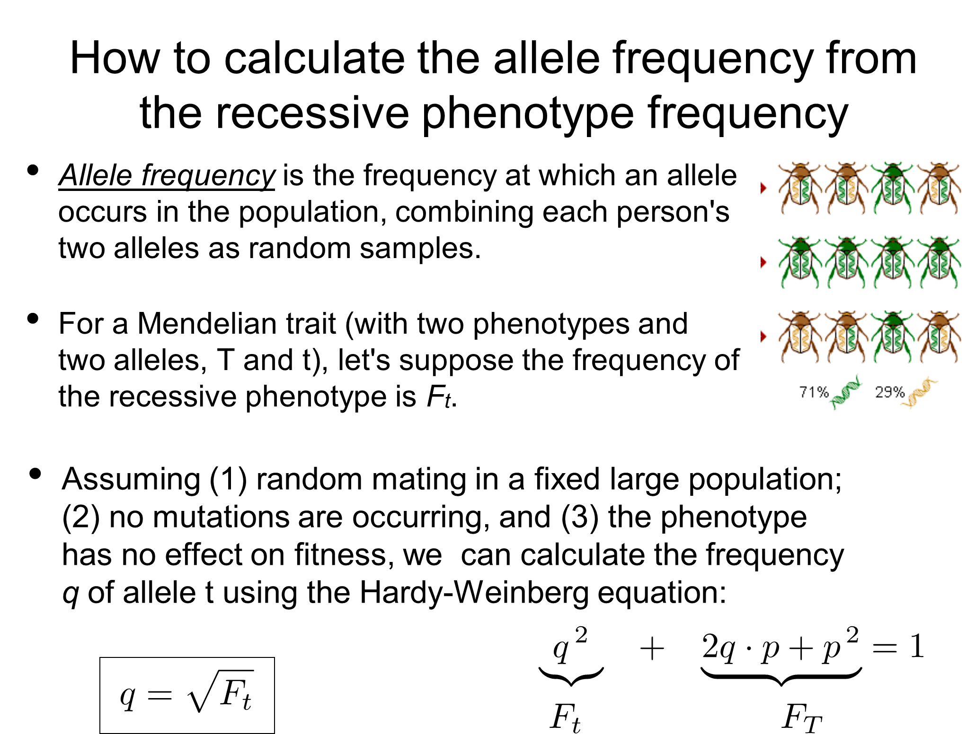**[SLIDE 17]**

**VOCABULARY**

**Allele** - one of two or more alternative forms of a gene that arise by mutation and are found at the same place on a chromosome

**Codominance** - neither allele can mask the expression of the other allele. E.G. ABO blood group, where alleles A and alleles B are both dominant and O is recessive. So if an individual inherits allele A from their mother and allele B from their father, they have blood type AB.

**Digenic** - induced by two genes; for our purposes, 1 trait controlled by 2 genes, each with 2 alleles

**Dominant Allele** - a variation of a gene that will produce a certain phenotype, even in the presence of other alleles

**Gene** - a unit of heredity which is transferred from a parent to offspring and is held to determine some characteristic of the offspring

**Genotype** - the genetic constitution of an individual organism

**Heterochromia** - is a difference in coloration, usually of the iris but can also be of hair or skin (e.g. a person has 1 green eye and 1 blue eye)

**Heterozygous** - when an organism contains two different alleles of a gene (e.g. Rr)

**Homozygous** - a particular gene that has identical alleles on both homologous chromosomes

**Incomplete Dominance** - a form of inheritance in which one allele for a specific trait is not completely expressed over its paired allele. This results in a third phenotype in which the expressed physical trait is a combination of the phenotypes of both alleles.

**Phenotype** - the physical expression, or characteristics of a trait

**Recessive Allele** - a variety of genetic code that does not create a phenotype if a dominant allele is present

**Sex-Linked Trait** - associated with genes found on sex chromosomes. In humans, the sex chromosomes are X and Y. Because the X-chromosome is larger, X-linked traits are more common than Y-linked traits.

**Trait** - a distinguishing quality or characteristic, typically one belonging to a person

**Materials**

Student Worksheet

Pencils, Markers, Crayons, Etc…

1 coin for each student

Spinner (optional, can use Google)

Colored construction paper

Glue

**Learning Objectives**

1. Students will understand the general process of heredity with Mendelian traits.
2. Students will understand the difference between **phenotype** and **genotype**.
3. Students will understand 2 types of Non-Mendelian heredity, **codominance** and **incomplete dominance.**
4. Students will learn how to apply the **Hardy – Weinberg Equation** to determine allele and genotype frequency.

**Procedure**

1. Hand out student worksheet.
2. Give each of your students a coin to flip.
   1. Heads = dominant / Tails = recessive
3. Students complete step 1 on the worksheet, skipping the 1st item.
   1. Alternative: Assign half the students to be XX and the other half to be XY for item 1.
4. Once they have completed step 1, have them pair up and complete their Punnett squares, step 2.
   1. If you chose to assign sex, XX and XY, have them pair up with someone who has a genotype different from their own, e.g. if they were assigned XX, they have to pair with someone who was assigned XY.
5. Using their Punnett squares, students will complete their Offspring traits, step 3.
6. Students will create their offspring using the materials provided. They will also come up with a backstory for their offspring.
7. Allow the students to share their process and final creation.
8. (Optional) Calculate population frequency of genes and alleles using items 2, 3, and 7 on the student “YOUR TRAITS” sheet (**Hardy-Weinberg: p2 + 2pq + q2 = 1)**
   1. For item 2, ask for a show of hands for students who had heterochromia. Using Hardy-Weinberg, Calculate percentage and plug in for q2 and complete the equation to find, the percentage of people who have a homozygous dominant genotype (p2) and heterozygous genotype.
   2. For item 3, ask for a show of hands for students who have ears that don’t wiggle. Repeat the process from step 1.
   3. For item 7, ask for a show of hands from students who have red fire. This percentage will give you q2. Use hardy-Weinberg to find the unknowns.

**(INSTRUCTIONS FOR SPECIAL ITEMS ON BACK)**

**\*\*SPECIAL ITEMS ON STUDENT WORKSHEET “YOUR TRAITS”\*\***

1. For item #5 the students will have a 4x4 Punnett square. You can choose to have them complete the 4x4 (**Option A, they will need to spin 2x: once for each Punnett Square**) or turn it into 2 2x2s (**Option B**) (see below). They will flip their coin 4 times. The 1st 2 times will determine A or a. the 2nd 2 times will determine B or b. For example: **1st flip = tails, 2nd flip = heads, 3rd flip = heads, 4th flip = tails**. This student will have a genotype of **aABb**. To complete the example Punnett Squares, let’s assume that both students have the same genotypes: **AaBb** and **AaBb**.

**(Option A)**

To complete the 4x4 Punnett Square, students will need to do an additional step. For their own set of 4 alleles, they will need to determine the 4 options for their A/B pairing since they will each pass on 1 A and 1 B together. Using our example of **AaBb** for both parents the 4 options would be:

**Parent 1 (same for Parent 2): 1) A**a**B**b = **AB, 2) A**aB**b Ab = Ab, 3)** A**aB**b = **aB,** and **4)** A**a**B**b** = **ab**

ab

aB

Ab

AB

|  |  |  |  |
| --- | --- | --- | --- |
|  |  |  |  |
|  |  |  |  |
|  |  |  |  |
|  |  |  |  |

AB

Ab

aB

ab

Once they complete the Punnett Square, they would use the Google spinner set to 16.

**(Option B)**

To create and complete the 2 2x2 Punnett Squares, we will 1st need to block out the 2 sections we don’t need (see below). Next, students will set up the Punnett Square as usual but with all 4 alleles. Using our example of both “parents” having the same genotype **AaBb**, here are the resulting Punnett Squares.

b

B

a

A

A

|  |  |  |  |
| --- | --- | --- | --- |
|  |  |  |  |
|  |  |  |  |
|  |  |  |  |
|  |  |  |  |

a

B

b

Once they complete the Punnett Squares, they will spin the 4-digit spinner 2x. The 1st spin will determine the **A**s and the 2nd spin will determine the **B**s.

Once the genotype is created, the phenotype will be as follows:

* If at least 1 dominant allele for each is present, **AxBx**, the phenotype is **SHORT**.
* If 1 complete set is recessive, but the other set has at least 1 dominant allele, **aaBx, Axbb, aaBB, or AAbb**, the phenotype is **MEDIUM**.
* If all alleles are recessive (**aabb**), the phenotype is **TALL**.

1. For item 6, this trait is linked to the X chromosome. This means that the student will flip the coin 1 time for each X chromosome they have (e.g. if the student is XY, they will flip 1 time; if the student is XX, they will flip 2 times). They will note their genotype with a superscript F for dominant and f for recessive). For example: student 1 is female, XX, so they flip the coin 2 times to determine the superscript for both Xs, flip 1 = tails (f), flip 2 = tails (f), which means their genotype is XfXf. Their partner is male, XY, so they only flip 1 time because they only have 1 X, flip 1 = heads (F), which means their genotype is XFY. They will use this info to complete items 1 and 6.