**Isle Royale, not Battel Royale: Then, Now, and Future**

Isle Royale is the largest island in Lake Superior. The island is approximately 45 miles in length and 9 miles wide. It is located about 12 miles south of the Canadian border, 20 miles southeast of Minnesota, and 53 miles north of Michigan. The only way to access the island is by seaplane or boat. Moose arrived at Isle Royale around 1900. Wolves first arrived at the island on an ice bridge from Canada in 1940. The Isle Royale moose and wolves have been studied since 1958. It is the longest continuous study of any predator-prey population. The ecosystem of the island is unique because it only contains one top predator, the wolf.

This activity has three parts:

Part 1 – THEN to NOW - Explore graphs, a video (0:00min-2:36), and a presentation to

understand the relationship between wolves, moose, and how they survive on the

island over time.

Part 2 – NOW to the FURTURE – Use the online graph to make predictions about what

might happen to wolves and moose on the island if their population sizes drastically change. Now, watch the rest of the video and decide what you would do if you had introduce a wolf to Island Royale.

Part 1 – THEN to NOW

1. Based on the background text in the box above, and the video answer the questions below:

* Why are the scientists studying the wolves on Island Royale? (1 sentence)
* What makes the ecosystem on Island Royale unique to scientists? (2 sentences)
* Why do you think scientists have chosen to study the predator-prey relationships of wolves in particular? What is so interesting or important about wolves? (2 sentences)

1. Based on what you know about predator-prey relationships, what do you think would happen to the WOLVES if……
   * All the moose were removed from the island?
   * Only 1 wolf was left on the island?
   * No new wolves came to the island?
2. Explore the online graph and look at the graph below.
   1. As the wolf population increases, what is happening to the moose population?
   2. As the wolf population decreases, what is happening to the moose population?
   3. Write down when the most wolves on the island as shown in the graph:

Population Size: __________ Year: ___________

* 1. Write down when the least wolves were on the island as shown in the graph:

Population Size: __________ Year: ___________

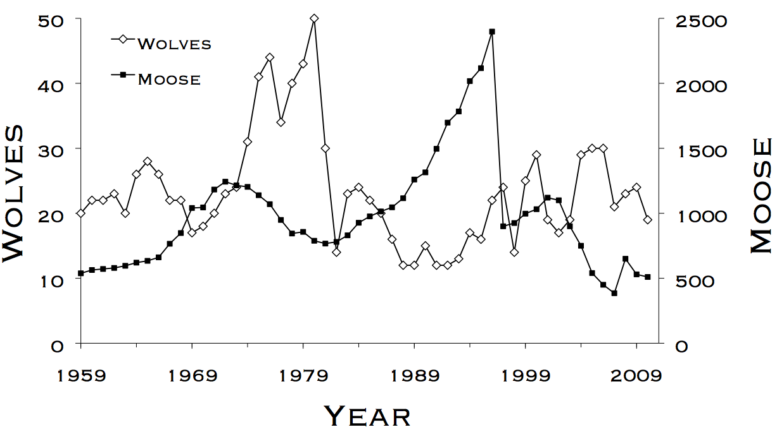

1. See the graph below, why do you think caused the drop in wolves starting at 1979 in? (3 possible reasons for the decline)

What happened here to the wolves? How does it relate to the moose here?



1. What other factors on the island might effect the wolves or moose that are not included in the graph? (e.g. food, disease, humans etc.)

**Project Update**

The Isle Royale project was the first time scientists were able to study how wolf population changes effect the moose population, and the overall ecosystem. However, in 2015 there were only 3 wolves left on Isle Royale. These last wolves were suffering from genetic mutations, isolation, and may not be able to repopulate the wolf population. As wolf numbers are drastically low, the moose on Island Royale are over populating the island and are over consuming their available food. If the moose population goes unchecked, they could destroy the ecosystem on the island. Currently, there are about 1400 moose on the island and only 3 wolves. What should wildlife researchers do to help the ecosystem of Island Royale?

Part 2 – NOW to the FUTURE (after part 2, watch the final video update)

1. Based Part 1 and the text above, and the video answer the questions below:

* Would you introduce wolves to the island? Why or why not? (2 sentences)
* Even if you did not say you should introduce wolves, if you had to give an amount, how many wolves should a researcher introduce to the island? (Note: in 1959 there were 563 moose, and 20 wolves). (2 sentences)
* Why do you think scientists have chosen to study the predator-prey relationships of wolves in particular? What is so interesting or important about wolves? (2 sentences)

Number 10-50:______

1. Now it is time to evaluate and clearly state your suggestion using evidence (e.g. data) from Part 1 and Part 2. Complete the following statement below based on how many wolves you would introduce.

I think that wildlife researchers should introduce _________ wolves to Island Royale. Based on historical data from 19___, the wolf population was at _______ and the moose population was at ______. Then in 19___ the moose population increased/decreased (circle one), and the wolf population increased/decreased (circle one). Because of this evidence, I think that if researchers introduced ____ (the number of wolves you are suggesting) of wolves, the moose population will go down and the wolf population will increase until there are too few moose, which will cause wolves to die and the moose population to grow. Introducing ____ amount of wolves will help Isle Royale ecosystem.